ERITOY COLLEGE
Good Homes Estate, AinaJakande Street,
Oke-Ira Bridge, Addo – Badore Road, Ajah, Lagos

FIRST TERM EXAMINATION, 2020/2021 Session
Class: Year 12 Subject: BIOLOGY
Time: 1hr 40mins Section: A (Objectives)
Instruction: Answer all the questions
1. Hepatitis B is a disease of the A. heart B. kidney C. liver D. pancreas
2. Dwarfism is caused by the deficiency of A. adrenalin B. insulin C.oxytocin D. somatotropin
3. The following are fleshy fruits except A. berry B. drupe C. legume D. sorosis.
4.Which of the parts of the skin consists of actively dividing cell? A. cornified layerB. Granular layer C. sweat gland D.malpighian layer.
5. The maintenance of a stable internal environment within the body of a mammal is known as
(a) homeostasis (b) osmoregulation (c) temperature (d) oxytocin
6.Which of the following conditions would result in a decrease in the production of anti-diuretic hormone A. abnormal high blood sugar level B.drinking large quantity of water C.increase in osmotic pressure D.period of strenuous activities
7.The amount of light entering the eyes is controlled by A. irisB.cornea C. conjuctiva D.sclera.
8.All of the following are involved in the maintenance of constant internal environment exceptA. kidney B.liver C. lungs D.skin
9Which of the following part of ear equalizes pressure on both sides of the eardrum semi-circular canals B.cochlea C.eustachain tube D. utriculus
10.Which of the following is not a function of the liver A. protein regulation B. heat production C. detoxification D. emancipation of cell.
11.Excessive breakdown of red blood cells, obstruction of bile duct is as a result of a disease called A. viral hepatitis B. jaundice C. gall stone D. cirrhosis
12.An example of a ductless gland is A. salivary gland B. gall bladder C. pancreas D. pituitary gland.
13.The largest internal organ of the body is A. lungs B. liver C.kidney D. skin
14.Which of the following is the master gland in the body A. pituitary gland B. salivary gland C. liver D.thyroid gland.
15.The blood vessels found in the dermis of the skin is basically for A.temperature regulation B .Sensation C. excretion D. respiration
16.The part of the skin where melanin and keratin are stored is A. malpighian layer B.cornified layer C.dermis D. granular layer
17.Which of these is not a function of hypothalamus? A.temperture regulation B.thirst C.sleep and temperament D.blood sugar regulation.
18.The hormone in a mature female that causes the release of mature eggs into fallopian tube is A. follicle stimulating hormone B.luteinizing hormone C. thyroxine D.thyroid stimulating hormone.
19.The hormone that regulate the amount of glucose in the blood is A. adrenalin B. auxin C. insulin D.prolactin
20. The function of the sebaceous gland is to A. secrete common salt B. secrete water and salt C. produce an oily secretion D.produce vitamin for the skin.
21.The central nervous system is made up of A.brain and liver B.liver and kidney C.kidney and skin D.brain and spinal cord.
22.Which of the following performs the function as the contractile vacuole of a unicellular organism? A.alimentary canal B. bladder C. kidney D. liver

23.The nerve cell at the dorsal root ganglion of the spinal cord is A. association neurons B.intermidate neurons C. sensory neurons D. motor neurons.
24..The chemical that fills the synapse to convert the electrical to chemical impulse during transmission of impulse along the neurons is A. choline B. acetyl ion C.acetyl choline D. acetylcholine terase
25.The part of the brain that controls the hormonal system is A. hypothalamus B.optic lobe C.auditory lobe D.pituitary gland
26.The nerve cell that is connected to effector is A.motor B.sensory C. Intermediate D.terminal
27.Knee jerk is an example of A.learned behaviour B. instinctive behaviour C. reflex action D. voluntary action
28.Each neuron consists of the following structures except A.cell body B. dendrites C.axon D. White matter
29.The grey matter of the spinal cord consists of A. bundles of fibres B. axons C.cell bodies and synapses D.dendrites.
30. The structure that help to nourish the eye cell is A. choroid B.sclera C. retina D.cornea
31.The main organ in the inner ear that is responsible for hearing is A. sacculus B.otholith C. utriculus D. cochlea
32.The bone of the ossicles at the center is A. anvil B.stirrup C.malleus D.stape
33.When the lens and the ciliary muscles lose their elasticity, a disease called A. astigmastism B.saquinting. C.presbyopia D. short sightedness
34.Which of the following parts of the eye is not involved in the image formation? A.retina B.lens C. yellow spot D. blind spot.
35.Which parts of the ear affects balance and posture? A. semi-circular canal B. cochlea C. oval window D. ossicles
36.Which of the following structures occupies the neural canal of the vertebral column? A.cerebellum B.hypothalamus C.medullar oblongata D.spinal cord
37.Which parts of the tongue is sensitive to bitter tastes? A.tip B.side C.middle D.back
Use the diagram below to answer question 38 only
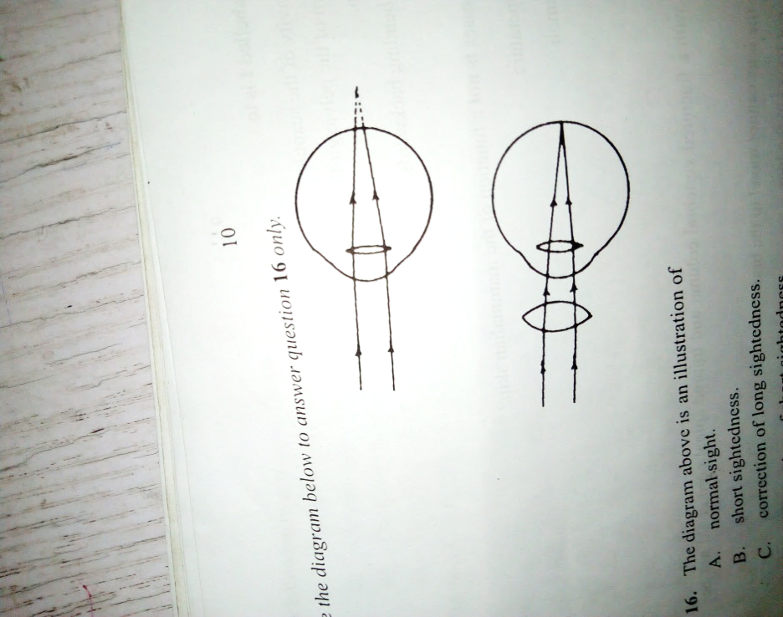

38.The diagram above is an illustration of A. normal sight B.short sightedness C.correction of long sightedness D.correction of short sightedness
39.The part of brain responsible for smelling is A. olfactory lobe B.auditory lobe C.optic lobe D.pons varolli
40.The underlisted structures are connected with reflex action (i) motor neurone (2) sensory neurone (3) muscle (4)skin (5) central nervous system. Which of the following represents the correct sequence of the reflex pathway A.3…1..5..2..4.. B.4…1…5…2…3 C.4…2…5…1…3 D. 3…2…5…1…3
41.All of the following are part of the nervous system except A. paraympathethetic B sympatheticC.peripheral nervous system D.edocrine system
The diagram below is an illustration of human brain and answer questions42 and 43
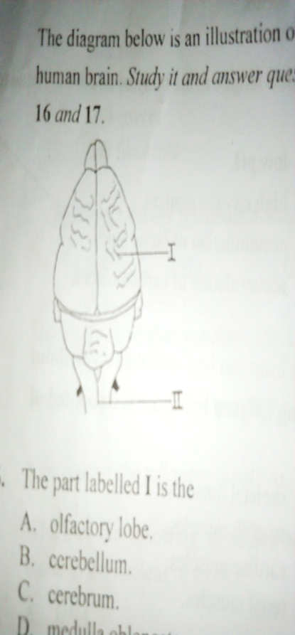

42. The part labeled I is the A.olfactory lobe B.cerebrum C. cerebellum D.medulla oblongata
43.The function of the part labeled II is that it controls A.posture and balance of the body B.temperature C.sleep D. excretion
44.Which of these is stored in the liver? A. amino acid B. glycogen C.glucose D.lipids
45.Sensory nerve endings in the skin are sensitive to A. heat B. light C.odour D.sound.
46.The hormones in plants responsible for the bending of plant shoot toward light source is located in .A. flower B.leaves C. light rays D. shoot tips .
47.The part of a neuron which carries impulse to the cell body is the A. myelin sheath B. axon C. dendron D. ganglia.
48.Which of the following will not affect population size A. predation B.competition C.immigration D.none of the above.
49.The succession that involves formation of new soil is A. primary B. secondary C. tertiary D. all of the above.
50. Which of these is not an example of a primary succession ? A. at the pond B. on a rock surface C. in estuary D. in a forest
51. Amphibians have the following features except A. cold blooded B. external fertilization C. four- chambered heart D. moist skin.
52. Which of the following group correctly illustrates their order of evolutionary trend? A. algae, mosses, ferns, flowering plants B. ferns, algae, mosses, flowering plants C. flowering plants, ferns, algae, mosses D. mosses, ferns, flowering plants, algae.
53. The following are features possessed by roundworm except .A. bilateral symmetry B. cylindrical body C. pointed ends D. segmented body
54. Which of these plants exhibits alternation of generation? A. mosses B. mushroom C. rhizopus D. yeast
55. Which of the following organisms has only one opening for ingestion of food and egestion of wastes? A.earthworm B. flat worm C. hydra D.roundworm.
56. The waste product of photosynthesis is A.ammonia B.carbonhydrate C .glucose. D oxygen.
57 Fats and oil are known as A. amino acid B.fatty acid C.glycerol D. lipids
58.During photosynthesis energy from the sun is converted to……….. energy A. chemical B.electrical C.heat D.kinetic.
59.The resolution of a microscope refers to its power to A.increase in an object” appearent size B. distinguish clearly between two objects C. scan the surface of an objects D.focus on an object
60. Which of the following substances is not a complex carbohydrate? A. Glycogen B.cellulose C.starch D.glucose.

THEORY; ANSWER 4 QUESTIONS
1a. Describe how the mammalian skin can serve as thermal regulator in hot room (3mk
b. Explain briefly the functions of the liver in relation to (i) carbohydrate (ii) proteins (iii)toxic substances (iv) temperature regulation (4mk)
c. Make a well labeled diagram of mammalian skin (10-12cm long) (3mk)

2a,State two functions each of the following structure (i) hypothalamus (ii)cerebrum (iii)cerebellum (3mk)
b. Make a labeled diagram of rabbit brain(10- 12cm )long (3mk)
c. Mention two elements that is involved in the transmission of impulse along a neuron (2mk)
d. State 2 differences between reflex and voluntary actions (2mk)

3a.In tabular form, state two differences between hormonal coordination and nervous coordination (2mk)
B .Name two hormones each involved in plant growth and animal growth state one their effect the organisms (4mk)
c. Describe the process of osmoregulation in man (2mk)
d .Make a labeled Diagram of a neuron between (10-12cm long) (2mk)

4a.Explain how mammalian body regulate their blood sugar (4mk)
b. Draw a diagram to show the location of the following glands; adrenal gland; thyroid gland; pituitary gland and ovary (2mk
c. Describe what happens when a student accidentally steps on the edge of an office pin and quickly raises his leg(4mk)

5a.Make a labeled diagram of mammalian eye (10- 12 cm ) long (3mk.)
b. State two eye defects and their corrections (3mk)
c. Define sense organ (1mk)
d. Explain why a person in a dark room is dazzled for some seconds when is exposed to bright sunlight(3mk)

